

**[FAST NUCES MANAGEMENT SYSTEM]**



January 23, 2021

FAST-NUCES

KARACHI

***[Rahib Hussain, 20K-1623, Sec B]***

***[Masab Bin Fakhar, 20K-0123, Sec B]***

***[Mohammad Usama, 20K-0190, Sec B]***

_____________________________________________________________________________________

1. **Acknowledgment**

Most of the project has been covered under the programming concepts taught in the classes. Although, to increase the attraction, and efficiency at some points in the program, few built-in/ helper functions were used from the internet. No specific website has been favored in our searches- the one with the best idea has been adopted. These websites includes geeksforgeeks and tutorialspoint.

**1. Introduction**

As the name of the project briefs the function of the project, this project is in regards to FAST Management which is delivered to the Visitor and the Student. Primarily, the program proms the user and student to sign up and input his/her basic information which includes their Names, CNIC and Phone Number for the Visitor While Name and Student ID for the student. The User and student will be offering with multiple choices in this project.

After entering the basic information the user and the student have a list of options. The User and student can select multiple choices from the menu.

The aim and motivation regrading this project was to emphasizes the general information regarding the FAST-NUCES for the outsider visitor and student too. If someone can’t visit the university physically due to some sort of typical issues so, he or she can know directly know all the scenario regarding university. Weather it is department, loan policy and other steps regarding FAST Uni so, we thought that we should make such a project which could help the new visitor and students. Who are willing to take admission in upcoming batch. This all was our motivations and aims regarding this project..

**2. Project Specification**

Project has specified the number of things .such as, it will help new user for all the details regarding university and its management ,it will also help students in every aspect such as time table schedule, loan policy, management and mail address of respective coordinates, and also in the end all the list of amount of cafeteria will be mentioned so it would create much easiness for students an new visitor too ..Project is being specified into number of ways but all will be regarding the management and basic alumnae of FAST -NUCES.

**3. Problem Analysis**

**Problems that compel me an my team to make this program was all regarding the issues faced by new user an upcoming students .If a new person visits university he shouldn’t be confused and be panic about the university management as the accounts offices ,Director addresses and other same sort of issues .If university launch this project onto the main gate it would create easiness for everyone .It would create much easiness for user an student if it be launch on the main gate.**

**4. Tools and technologies used**

**IDES used:**

Dev C++ COMPILER IS USED FOR COMPILATION OF THIS PROJECT.

**4.1. Libraries:**

* + - 1. #include < stdio .h>, ( to take inputs and outputs)...
      2. #include < fscanf > , used for ("filename.user.txt") to read from files
      3. fprintf ("filename.txt") -> use to write in files.
      4. #include <string>/<cstring>>, used for gets() to take strings as input

No Database but simple filing is used through txt files, or framework used.

**4. Class diagram**

Here we have divided our project into different classes that are user and student and we have assigned different types of variables for them that will be defined below down by their complete syntax. Main aspects of projects are user/visitor and student that will be carried out in whole the project .Variables for each function will be using through out the project .

**Class Student**

**Class visitor**

**int rollno;**

**char name[100];**

**int** rollno;

**char** name[100];

**int** id;

**char** name [100];

**int** cnic;

**char** name [100];

**char** phnum[100];

**Class Functions**

**void** input(**void**);

**void** inputstudent(**void**);

**void** societies(**void**);

**void** cafeteria(**void**);

**void** library(**void**);

* **Class visitor:** This class is made to highlight the variables for the class visitor that will be name phone number an CNIC of the user that will pe provided by user at the time of entrance.
* **Class Student:** This class is used to highlight the variables for the student that will be student roll-num, name at the time of entrance.
* **Class Functions:** This class is used to highlight the functions that have been made in this project that are ,input void, input student, input cafeteria ,input library and cafeterias .This will be our main functions that will be using ,defining an calling in all the project.

**5. Link to source**

**Google Drive:**

**6. Future work**

Firstly as we have made this project in 1st semester by applying different functions for the purpose of easiness for the user and student who are willing to join fast university .In future we have to work on this project more precisely ,and we have to bring this project on university level in next coming days. In future we will work on GUI in different steps of this project .As this project is totally for the university so we will try more to bring this project on university level and we will make it better in many ways by applying different functions an features. In future we are trying also to use it for security features too so it can provide security for fast university also.

**7. Project Breakdown Structure**

As the project is completed by the untiring efforts of all the team ,the workload was too much high but all manage it by their skills .Everyone made its part best in this project .At the time of online classes we have conducted 2 ,3 meetings at zoom which helped us more to make our project best and we done it. Team work needed a lot in any work ,and it is best that we have worked all together an completed in short passage of time ,while our exams were going on but day by day we work on it .Team mates are specially appreciated for their great cause of such efforts /.Task was given to us but we done it in a best way .Credit goes to whole the team.

**8. Result**

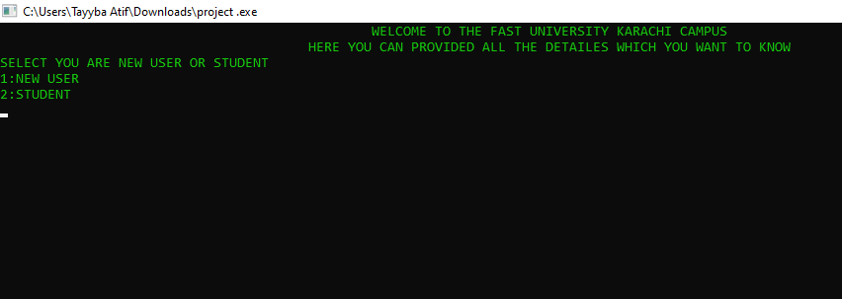

**This is the main console image of the project in which the main console body is being shown in which main aspects are being show that are New user and Student.**

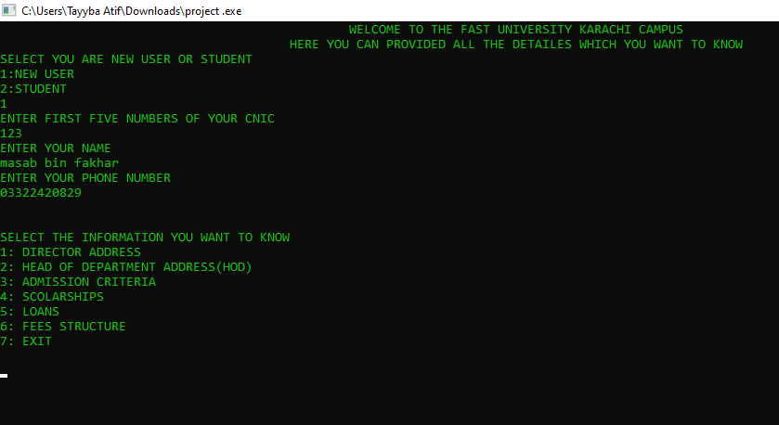

**These all are the main aspects of project simply the whole working of project in which we have entered required data for entrance and after it the results on console is being shown.**

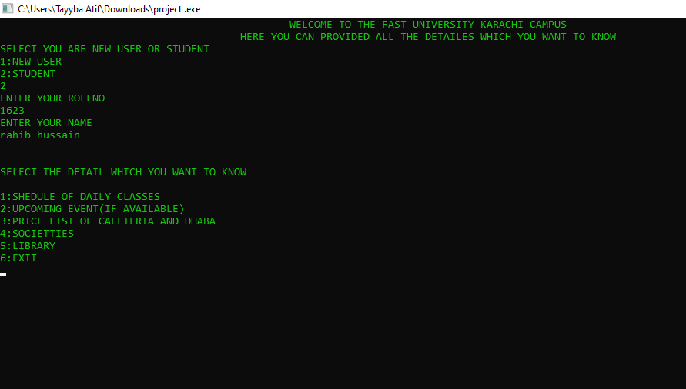

**This is the output of scheduled classes function. In this function we will be seeing the schedule classes menu for all the freshmen of all the respective departments.**

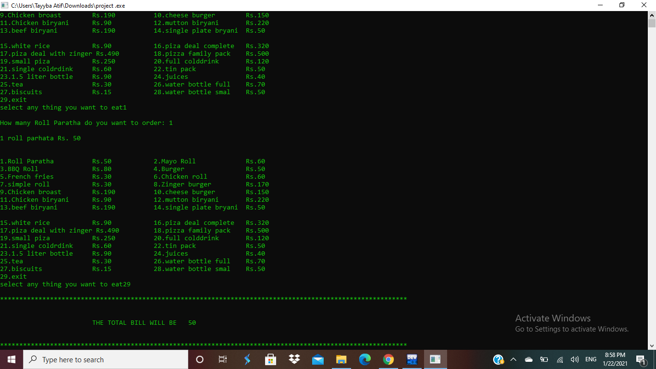

This is the output console of the cafeteria function in which we will see the list of items being offered at cafeteria with the price lists …in end we will also see the final outcome in the shape of returning amount after purchasing all the items, an total bill will also be shown ..

**Conclusion**

**To sum up the all project I would simply say that these projects are very helpful for our skill building without these we cant make or logic an build our skills for the next semester .In this project we learned many new things and methods to handle multiple issues regarding our project an given tasks.**

We try new methods an techniques to solve this project .various type of functions were used by us in this project ,really learned a lot in this project and will be learning ahead too

Thanks for such great faculty who assigns us different type of projects for our skill an logical building.

Thank you so much for bringing your unique teaching style to our university and being one of the best teachers we have on campus. Thank you for being a fantastic teacher!